**Inventory OLTP System**

An inventory management OLTP system is essential for a pharmacy for multiple reasons like

Stock Level Monitoring

* Prevents stockouts, as shown by critical low inventory levels (quantity_on_hand = 0) for medications in certain stores
* Enables real-time tracking of quantity_on_hand against reorder_level thresholds

Order Processing

* Manages concurrent order processing across multiple stores with various statuses like "Processing," "Filled," and "Ready for Pickup.
* Tracks order fulfillment from placement to completion, ensuring medication availability

Supply Chain Management

* Facilitates automated reordering when inventory reaches reorder levels
* Manages varying demand patterns across different locations and products

**ERD:**

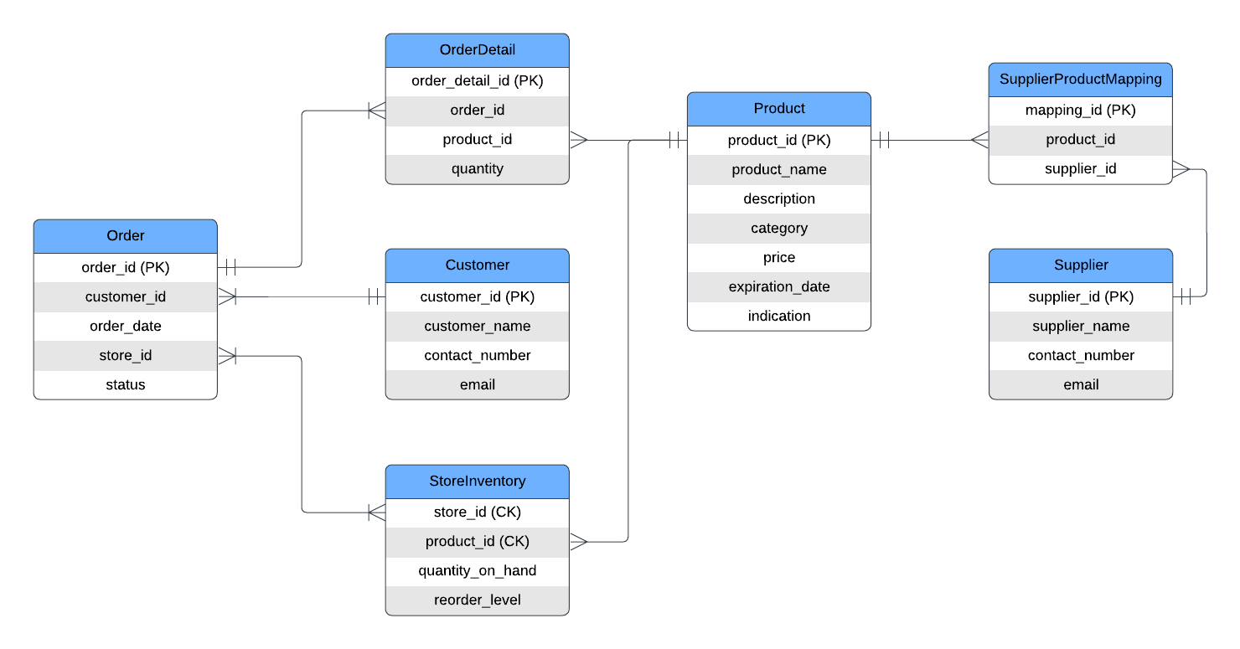

**Entities and Relations:**

**1. Products Table**

* product_id (Primary Key): Unique identifier for each product.
* product_name: Name of the product.
* description: Description of the product.
* category: Category of product
* price: Price of the product.
* expiration_date: Expiration date for perishable items
* indication: the disease that is treated with the product

**2. StoreInventory Table**

* store_id (Primary Key): Unique identifier for each store inventory
* product_id: Foreign key linking to the Products table.
* quantity_on_hand: Current quantity in stock.
* reorder_level: Quantity at which a reorder should be triggered.

**3. Suppliers Table**

* supplier_id (Primary Key): Unique identifier for each supplier.
* supplier_name: Name of the supplier.
* contact_info: Contact information for the supplier.
* email: Email of the supplier

**4. Orders Table**

* order_id (Primary Key): Unique identifier for each order.
* customer_id: Foreign key linking to the Customers table.
* order_date: Date when the order was placed.
* store_id: store at which the order was placed
* status: Current status of the order (e.g., pending, shipped, delivered).

**5. OrderDetails Table**

* order_detail_id (Primary Key): Unique identifier for each order detail record.
* order_id: Foreign key linking to the Orders table.
* product_id: Foreign key linking to the Products table.
* quantity: Quantity of the product ordered.

**6. Supplier Product Mapping Table** - Information about which supplier can deliver a product

* mapping_id (PK) - Unique identifier for each mapping record.
* product_id (FK) - Foreign key linking to the Products table.
* Supplier_id (FK)- Foreign key linking to the Supplier table.

**7. Customers Table** - Not necessary for the OLTP system, will be helpful for deriving insights like customer purchase pattern

* customer_id (Primary Key): Unique identifier for each customer.
* customer_name: Name of the customer.
* contact_info: Contact information for the customer.
* email: Email of the customer

**DDL Scripts:** <https://drive.google.com/file/d/18-cOrUgEy-7ude5huc1dghu-BVkWqSUf/view?usp=sharing>